

Carbon Reduction Program (CRP) FY26-27 Guidebook

Funding in Fiscal Year (FY)2030
Last Updated: October 2026
This application template has been modified for use by applicants within the Northeast Minnesota Area Transportation Partnership (NEMNATP). This includes applicants from Aitkin, Carlton, Cook, Itasca, Koochiching, Lake, Pine, and St. Louis Counties.
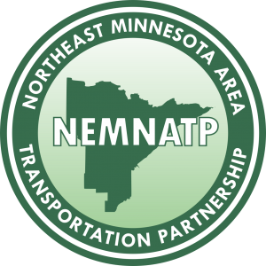

Table of Contents
Contents
How to use this guide 2
Carbon Reduction Program Overview 3
Funding Target Estimates 3
Eligible Project Types 4
Electrification* 4
Travel Options 5
Low Carbon Infrastructure and System Management 7
Solicitation timeline 8
Evaluation Criteria 9
Cost-effectiveness 9
Co-benefits 10
Project scoring 12

How to use this guide

This Toolkit Guide is designed for MnDOT Districts, Metropolitan Planning Organizations (MPOs) and Area Transportation Partnerships (ATPs) responsible for selecting Carbon Reduction Program (CRP) projects. MPOs and ATPs are encouraged to use the materials in the Toolkit to release a project solicitation. Districts receive separate CRP funds that do not flow through the ATPs. For those funds, Districts are encouraged to use the materials in the Toolkit to evaluate and select CRP projects.
This document is broken into three sections based on users:
- Program information
- Solicitation materials
- Project review materials
Annual guidance on solicitations will be posted to the MnDOT CRP website. The website will have the
most updated guidance and information on the CRP funding and programming.

Carbon Reduction Program Overview
The Infrastructure Investment and Jobs Act (IIJA) established the CRP which provides federal funds for projects designed to reduce carbon emissions from surface transportation. The legislation also requires each state to develop a Carbon Reduction Strategy¹ (CRS) in consultation with MPOs to identify projects and strategies to support the reduction of transportation emissions. In Minnesota, the CRS was completed in November 2023 and submitted to FHWA for review and approval. MnDOT developed the Minnesota CRS in coordination with MPOs, ATPs, the public, transportation advocacy groups and other partners across Minnesota. Implementation of the CRS requires coordination among MnDOT and partner agencies.
The CRP provides Minnesota with approximately $20.9 million annually over five years to fund projects that reduce carbon emissions from surface transportation. Program funding is distributed across the state, with some funds allocated proportionally based on population². MnDOT Districts, MPOs and ATPs will select projects to receive CRP funding.
Areas that receive funding will use a consistent set of criteria and scoring techniques detailed in this document to support prioritization and selection of projects. While the primary intent of the CRP is to advance projects that reduce carbon from the surface transportation sector, the Minnesota CRS also advances goals of economic opportunities, safety, transportation access and resilience.

Funding Target Estimates

The 2026/2027 TA solicitation includes funding being made available in Fiscal Year (FY) 2031. Funding target estimates are provided below.

Fiscal Year | Funding Availability
2030 | $600,000

*Please Note: As of the solicitation announcement (October 5, 2026), Federal funding targets are still in draft. The estimate above is consistent with prior fiscal year authorizations. Finalized funding targets will be communicated to applicants and sponsors at our earliest convenience.

This solicitation is open to all eligible applicants outside of the Duluth-Superior MPO area.

¹ “Carbon Reduction Strategy 2023”, https://edocs-
public.dot.state.mn.us/edocs_public/DMResultSet/download?docId=36928262, MnDOT, (2023).
² Under federal law, within each state, 65% of CRP funds must be allocated to areas of the state in proportion to population size and 35% of CRP funds may be allocated in any area of the state (23 U.S.C. 175(e)).

Eligible Project Types
There are many project types that can address the goals of the CRP and reduce emissions from the transportation sector. The Minnesota CRS prioritizes projects in three broad strategy categories: electrification, travel options and low carbon infrastructure and system management. Most of the projects identified in the CRS are eligible for CRP funding, with exceptions identified in the sections below.
As CRP formula funds are identified in the Infrastructure Investment and Jobs Act (IIJA) which expires at the end of fiscal year 2026, and it is unknown what will be included in the next federal transportation reauthorization bill beyond Fiscal Year 2026, MnDOT recommends CRP fund applicants apply for travel options and low carbon infrastructure eligible project types for fiscal year 2027 through 2030.

Electrification*
The primary goal of electrification projects is the decarbonization of the vehicle fleet in Minnesota. Electric vehicles (EVs) and other zero emissions vehicles (ZEVs) are critical to achieving the emissions reduction goals set forward in the CRS because they can reduce transportation emissions for traveling that cannot be reduced or shifted to another mode. There are a wide range of electrification projects and projects that support EVs or ZEVs. Projects can support three strategies in the CRS, but may not be eligible under the next federal transportation authorization act:
- Install EV or ZEV charging infrastructure.
- Purchase or leasing EVs or ZEVs.
- Support EV and ZEV adoption through outreach and education.

*Applicant Note: Applicants should be aware that federal guidance and priorities for the Carbon Reduction Program are currently evolving. Before investing significant time in an application, we encourage you to contact ARDC Senior Planner, Travis Houle (thoule@ardc.org) to discuss whether your project aligns with current program direction.
Figure 1: 2023 Minnesota CRS Electrification priority strategies and project types, MnDOT 2023³
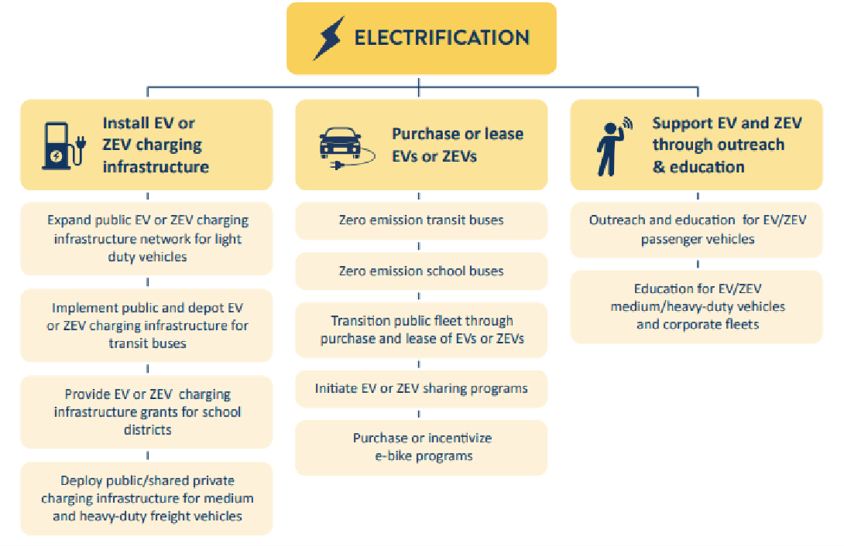

Potentially ineligible under next federal transportation authorization bill

Travel Options
Travel options projects reduce per-capita vehicle miles traveled (VMT). Reducing VMT supports achieving the emissions reduction goals set forward in the CRS because a reduction in per-capita VMT reduces per-capita transportation emissions. Eligible projects can support six strategies in the CRS:
- Install and maintain infrastructure network improvements for walking, rolling and biking.
- Plan, design and engineer infrastructure network improvements for walking rolling and biking.
- Implement context sensitive design for travel options.
- Add high-capacity transit options.
- Add intercity and regional public transit options.
- Implement travel demand management.

³ “Carbon Reduction Strategy 2023”, MnDOT, (2023).

Figure 2: 2023 Minnesota CRS Travel Options priority strategies and project types,
MnDOT 2023
(CRP ineligible project types noted)⁴
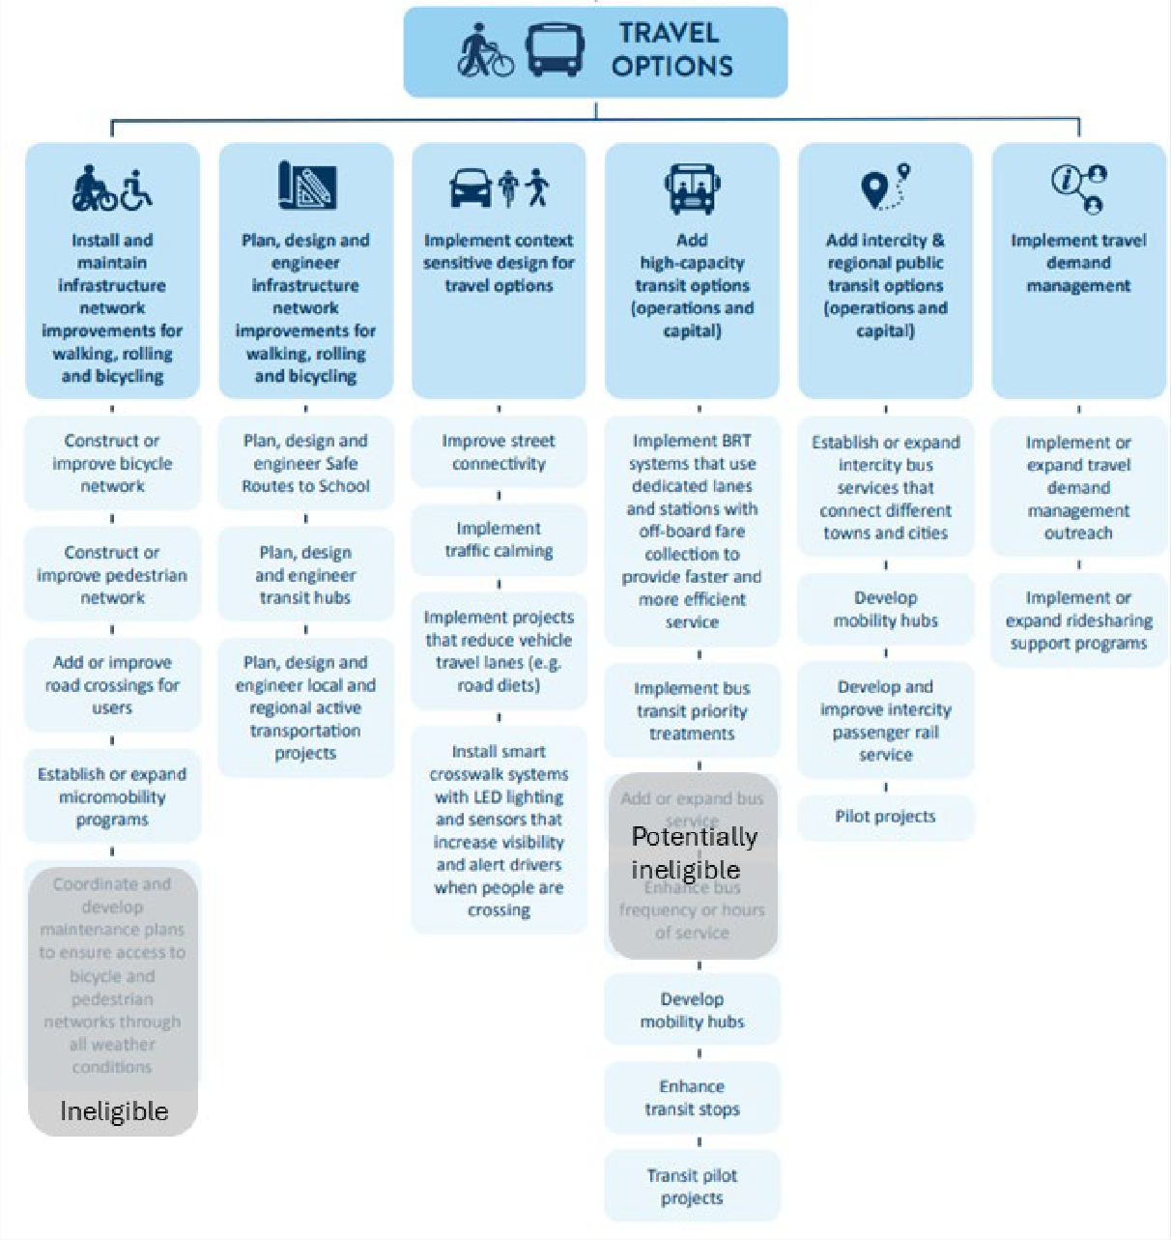

⁴ “Carbon Reduction Strategy 2023”, MnDOT, (2023).

Low Carbon Infrastructure and System Management
Low carbon and infrastructure system management projects reduce emissions throughout the entire transportation process, from construction and maintenance of infrastructure to vehicle operations. These projects support the use of:
- Low carbon materials in project construction.
- Improving construction and maintenance practices.
- Reducing emissions associated with transportation infrastructure and vehicle operations. Eligible projects can support three strategies in the CRS:
- Optimize transportation systems management and operations.
- Utilize low carbon methods for construction and maintenance of transportation infrastructure.
- Support renewable energy generation.
Figure 3: 2023 Minnesota CRS Low Carbon Infrastructure and System Management priority strategies and project types, MnDOT 2023
(CRP ineligible project types noted)5
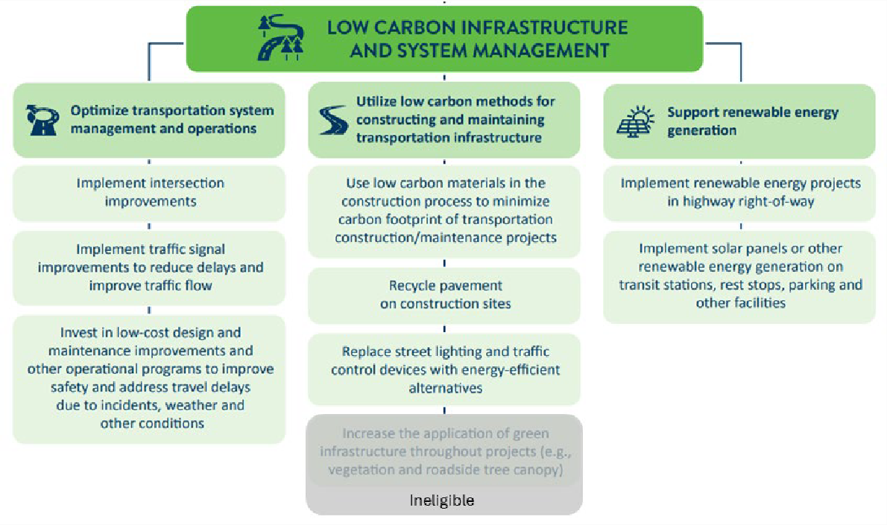

⁵ “Carbon Reduction Strategy 2023”, MnDOT, (2023).

Solicitation timeline
Project solicitations will be conducted by MPOs and ATPs and specific dates will be determined by those entities. The timeline should follow the following outline:
- Determine solicitation Project Review and Scoring Committee
- Convene Project Review and Scoring Committee to determine:
  - Will the solicitation occur in one-part or two-part submittals (more information in project selection and scoring section of this document)
  - What percentage of the scoring will be for cost-effectiveness of carbon reduction?
  - Timeline of solicitation
  - Solicitation materials
- Develop solicitation, a template is provided in this document
- Open the Letter of Intent (LOI) period
- Collect LOIs
- Review LOIs with potential applicants and notify applicants if they should apply for funding
- Open full application period
- Collect project applications
- Selection committee meets to review and select applications
- Projects approved by applicable boards or committee (e.g., award projects)
- Incorporate the selected projects in the TIP (if applicable) and STIP
The MnDOT CRP website will provide information as to what years of funding are available for solicitation each year. MPOs, ATPs and District staff should check the website for updates.
2025-2026 Solicitation timeline
- Monday, Oct. 5, 2026 – Announce solicitation; Open LOI period
- Friday, Oct. 30, 2026 – Deadline for applicants to submit LOI
- Monday, Nov. 2, 2026 – LOIs review process by RDO/MPO/MnDOT Districts begins
- Monday, Nov 3, 2026 – Official start of full application period
- Friday, Jan. 10, 2027 – Deadline for applicants to submit full applications
Applicants will be contacted in the early Spring 2027, with the results from their submission.

Evaluation Criteria
Each application includes a section for a project description, project timeline and milestones to showcase the project’s eligibility, quality and readiness. These items will be reviewed to identify project readiness.
Projects will be evaluated based on cost-effectiveness and the following four co-benefit categories. Cost-effectiveness will account for a minimum of 50% of the project scoring. The final score for a project is determined by adding the cost-effectiveness score with the co-benefit score, giving each project a score out of 100 points.
The following sections detail the cost-effectiveness and co-benefit evaluation and scoring processes.

Cost-effectiveness
The primary metric against which projects will be selected is the cost-effectiveness of a project’s carbon reduction. Applicants will need to use the Carbon Emissions Tool (CET) to calculate a project’s carbon reduction and associated cost-effectiveness. The basic equation for cost-effectiveness is in Figure 4. The CET Instructions and Tips provide guidance on how to use the CET.
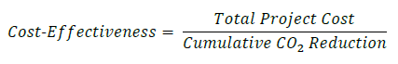
Figure 4: Equation for calculating cost-effectiveness of a project’s carbon reduction, MnDOT CET 2024
To be able to score projects, a consistent scoring scale needs to be established. This means that the cost-effectiveness of carbon must fit into a 20-point scale. Table 1 shows how the 20-points are distributed based on carbon cost-effectiveness. Projects with a cost-effectiveness value of greater than $10,001 per metric ton of carbon dioxide equivalent emissions will receive 0 points for cost-effectiveness of carbon emissions reduction.
Table 1: Carbon Reduction Program cost-effectiveness of carbon emissions scoring, MnDOT September 2024

Starting value of Cost-effectiveness of carbon emissions reduction per  MT of CO2e | Ending value of Cost-effectiveness of carbon emissions reduction per MT  of CO2e | Cost-effectiveness of carbon emissions  reduction score (points)
$ - | $ 500 | 20
$ 501 | $ 1,000 | 19
$ 1,001 | $ 1,500 | 18
$ 1,501 | $ 2,000 | 17
$ 2,001 | $ 2,500 | 16
$ 2,501 | $ 3,000 | 15
$ 3,001 | $ 3,500 | 14
$ 3,501 | $ 4,000 | 13
$ 4,001 | $ 4,500 | 12

Starting value of Cost-effectiveness of carbon emissions reduction per  MT of CO2e | Ending value of Cost-effectiveness of carbon emissions reduction per MT  of CO2e | Cost-effectiveness of carbon emissions  reduction score (points)
$ 4,501 | $ 5,000 | 11
$ 5,001 | $ 5,500 | 10
$ 5,501 | $ 6,000 | 9
$ 6,001 | $ 6,500 | 8
$ 6,501 | $ 7,000 | 7
$ 7,001 | $ 7,500 | 6
$ 7,501 | $ 8,000 | 5
$ 8,001 | $ 8,500 | 4
$ 8,501 | $ 9,000 | 3
$ 9,001 | $ 9,500 | 2
$ 9,501 | $ 10,000 | 1
$ 10,001 | $ - | 0

Co-benefits
There are many co-benefits that projects can have in addition to carbon reduction. In alignment with the
Minnesota CRS, four primary co-benefit categories have been identified.
- Economic opportunities
- Safety
- Access
- Resilience
Each co-benefit is scored on a scale of five points, amounting to a maximum of 20 total points for each
proposed project. A description of each point level is provided in Table 2.
Each applicant should provide separate narrative descriptions for each co-benefit category (i.e., a narrative for economic opportunities, another narrative for safety, etc.). These narratives should describe qualitatively, quantitatively, or both, how the proposed project will fulfill each co-benefit category. When writing narratives applicants are encouraged, but not required, to use established datasets, benchmarks, best practices, standards set forward in planning documents (i.e., Statewide Multimodal Transportation Plan) or other similar material to identify how the co-benefit is met by the project.
Applicants are encouraged to respond to each co-benefit in the application. If no connection to a co-benefit can be found in a project, the project may still be eligible for funding. Applicants are still encouraged to apply, as a project may be selected even if it does not receive a high score for all co-benefits.

Table 2: Scoring Scale for Co-Benefits, MnDOT 2024

Score | Description
0 | This project demonstrates no connection to the co-benefit.
1 | This project shows minimal connection to the co-benefit with little to no documentation in datasets, plans or narrative.  Narrative text describes a weak connection to a co-benefit with no supporting datasets or plans provided.
2 | This project shows a moderate connection to the co-benefit with some documentation in  datasets, plans or narrative.  Narrative text makes the case that there is a connection to the co-benefit, based on the applicant’s understanding, but there are no further datasets or plans provided.
3 | This project shows good connection to the co-benefit somewhat documented with datasets,  plans or narrative.  There are plans or maps with data that shows a connection to the co-benefit Narrative text  makes a connection between the data provided and the co-benefit.
4 | This project shows well-defined connection to the co-benefit with well documented datasets,  plans or narrative.  There are plans or maps with data that shows a connection to the co-benefit. Narrative text provides thorough detail on how the project will benefit area communities using the data provided.
5 | This project shows outstanding connection to the co-benefit through thoroughly documented datasets, plans or narrative.  There are comprehensive planning, engineering or economic focused studies carried out prior to or as part of the project development process that provide detailed and specific connections to the co-benefit.

Project scoring
Using the above consistent scoring methods, the cost-effectiveness and co-benefits criteria are combined to create a composite score for each project. This composite score are used to rank projects. Composite scores may be entered into the CRP Project Scoring tool, which provides a total score out of 100 for each project. This score is calculated using the equation in Figure 5.
Figure 5: Cost-effectiveness scoring equation, MnDOT 2024

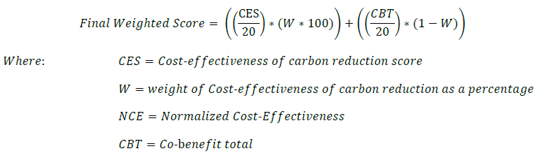
In Figure 5, MPO and ATP Project Review and Selection Committees are able to modify the weight of cost-effectiveness of carbon reduction and co-benefits. The default weight is 50% for cost-effectiveness and 50% for co-benefits, meaning that the sum of the co-benefits and the cost-effectiveness of carbon reduction are weighted equally. To further prioritize carbon cost-effectiveness in project selection, an ATP or MPO may increase the percentage that the cost-effectiveness of carbon reduction is weighted to higher than 50% (it cannot be lower than 50%). This allows regional agencies to determine the importance of the cost-effectiveness of carbon reduction and each co-benefit based on their regional priorities.
This weight is incorporated in the formula and represented by the ‘W’ (Figure 5). This maintains the 100-point scale for final scores but allows for different weights between the cost-effectiveness of carbon reduction and co-benefits.
An ATP or MPO may further prioritize their regional priorities by add further scoring weights to the overall score. When this occurs, early coordination with MnDOT OSPH Carbon Reduction Program Coordinator should occur to ensure a clear and transparent process occurs and these additional score weights are transparent to the potential applicants prior to the solicitation being released.

