

Promoting Resilient Operations for Transformative, Efficient, and Cost-Saving Transportation (PROTECT)
PROTECT Formula Program FY26-27 Solicitation Guidebook
Funding in Fiscal Year 2031
Last Updated: October 2026
Table of Contents
Program Information 3
Program Funding Target 3
2026-2027 Solicitation timeline 3
Eligible Projects 4
Table 1: Resilience Project Categories and Climate Hazards, Minnesota Resilience Improvement Plan 5

Program Information
The Promoting Resilient Operations for Transformative, Efficient, and Cost-Saving Transportation (PROTECT) Formula Program was authorized under the Bipartisan Infrastructure Law in 2021. The $7.3 billion PROTECT Formula Program provides funding to help make surface transportation more resilient to natural hazards, including climate change, sea level rise, flooding, extreme weather events, and other natural disasters through support of planning activities, resilience improvements, community resilience and evacuation routes, and at-risk coastal infrastructure. The current federal appropriation for this program in Minnesota is approximately $115 million or $23 million annually over federal fiscal years 2022-2026 and requires a non-federal match. Applications for formula funds will be administered by the applicable Area Transportation Partnership (ATP) and/or Metropolitan Planning Organization (MPO).

Program Funding Target
The 2026-2027 NEMNATP PROTECT solicitation includes funding being made available in Fiscal Year (FY) 2031. Funding target estimates are provided below.
Fiscal Year | Funding Target Estimate
FY2031 | $420,000*
*Please Note: As of the solicitation announcement (October 5, 2026), Federal funding targets are still in draft. The estimate above is consistent with prior fiscal year authorizations. Finalized funding targets will be communicated to applicants and sponsors at our earliest convenience.

2026-2027 Solicitation timeline
- Monday, Oct. 5, 2026 – Announce solicitation; Open LOI period
- Friday, Oct. 30, 2026 – Deadline for applicants to submit LOI
- Monday, Nov. 30, 2026 – Official start of full application period
- Friday, Jan. 10, 2027 – Deadline for applicants to submit full applications
Note: Applicants will be contacted in early Spring 2027 with the outcome of ATP project review.

Eligible Projects
The Minnesota Resilience Improvement Plan (RIP) identifies top climate hazards in Minnesota. Eligible projects must address resilience to at least one of the seven climate hazards outlined in the RIP:
- heavy precipitation and flooding;
- extreme temperatures;
- freeze-thaw changes;
- abnormal winter weather;
- wildfire;
- landslides; and/or
- coastal erosion (along Lake Superior’s north shore)
The RIP also identifies specific resilience project categories that address each climate hazard or a combination of hazards. Within each category are specific projects types or resilience improvements that are eligible for funding, per PROTECT Formula Program guidance.
Table 1 lists eligible project categories, related climate hazards and example project types. This is not an exhaustive list of eligible project types and selecting the appropriate resilience improvement is a project-specific decision that is context-dependent. MnDOT Office of Sustainability and Public Health staff are available to advise on selecting the appropriate resilience improvement and confirming with local FHWA Division staff that an improvement is eligible under the PROTECT Formula Program.

Table 1: Resilience Project Categories and Climate Hazards, Minnesota Resilience Improvement Plan
Project Category | Climate Hazards | Project Types/  Resilience Improvements
Bridge Reconstruction and Elevation of Roads in at-risk flood zones | Heavy precipitation and flooding | Enhance bridge design;  Increase freeboard clearance;  Riprap and bridge foundations;  Channel design/Monitoring  (i.e., monitoring as part of a statewide planning process)
Roadway Embankment Armoring | Heavy precipitation and flooding | Vegetated riprap;  Permanent erosion control mat;  Articulated blocks in a sag point
Culvert Replacement/Urgent Repairs | Heavy precipitation and flooding, Freeze-thaw cycles, Wildfire | Increasing culvert size;  Replacing poor-condition culverts
Floodplain Conservation/Preservation | Heavy precipitation and flooding, Freeze-thaw cycles | Restore inland wetlands;  Flood setbacks;  Bank vegetation and seeding;  In-stream structures;  Bioswales and bioretention basins;  Trees
Landslide and Rockfall Protection | Heavy precipitation and flooding, Freeze-thaw changes, Wildfire, Landslides | Surface water management;  Rockfall mitigation;  Debris flow catchment;  Reduce driving force on slopes;  Underground drainage;  Vegetation and seeding;  Bioengineering and biotechnical stabilization
Drainage Area Enhancements | Heavy precipitation and flooding, Extreme temperatures, Freeze-thaw cycles | Snow fences;  Outcome-focused partnerships with other government units, landowners, and land managers;
Wildfire Protection | Wildfire | Defensible space;  Fire-resistant landscaping;  Vegetation management;  Hardening
Armoring and Natural Design to protect Lake Superior | Coastal erosion, Heavy precipitation and flooding, Landslides | Sea walls and bulkheads;  Revetments and slope protection;  Groins and jetties;  Living shorelines/shoreline stabilization;  Barrier Islands;  Sand and rock beaches

Appendix A: Estimating recurrence interval of flooding events
The following instructions are provided as an optional guide to obtain the estimated recurrence interval of flooding events at the proposed project location. This is one metric that can be used to convey the potential climate hazard risk posed by heavy precipitation and flooding to an asset/facility.
- Compile asset/facility location, date of flooding event, and upstream watershed location (if known).
- Gather the rainfall estimate based on gage-corrected rainfall data from the National Water Prediction Service Website: https://water.noaa.gov/
Step 1: On right side panel, click box on “Enabled” under “Precipitation Estimate”.
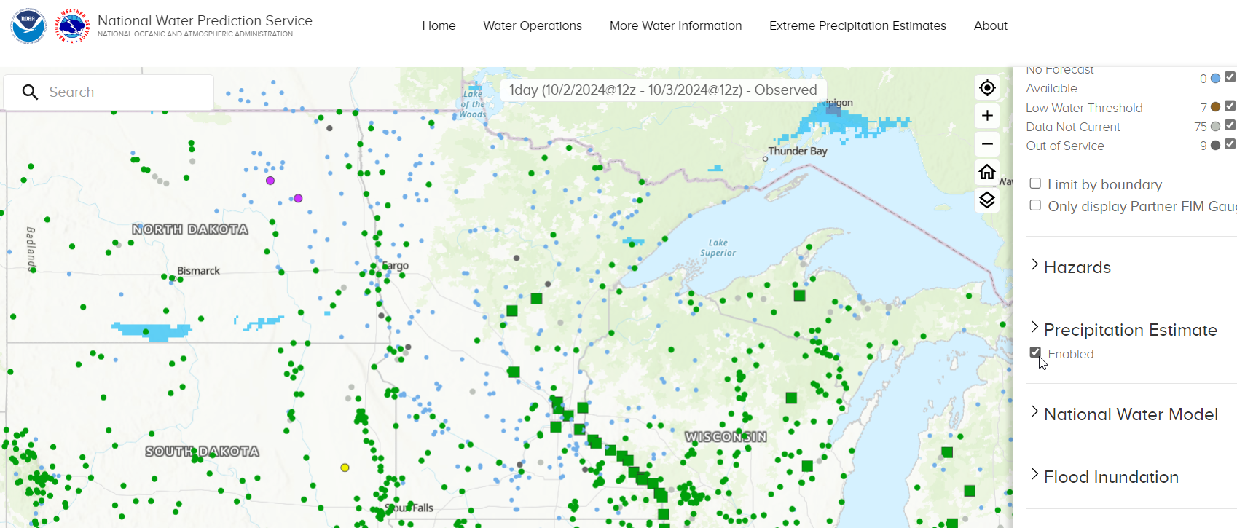
Step 2: Click arrow next to “Precipitation Estimate” to open the options.
Step 3: Click box on “Display estimated precipitation on hover” and enter the date of the flooding event.
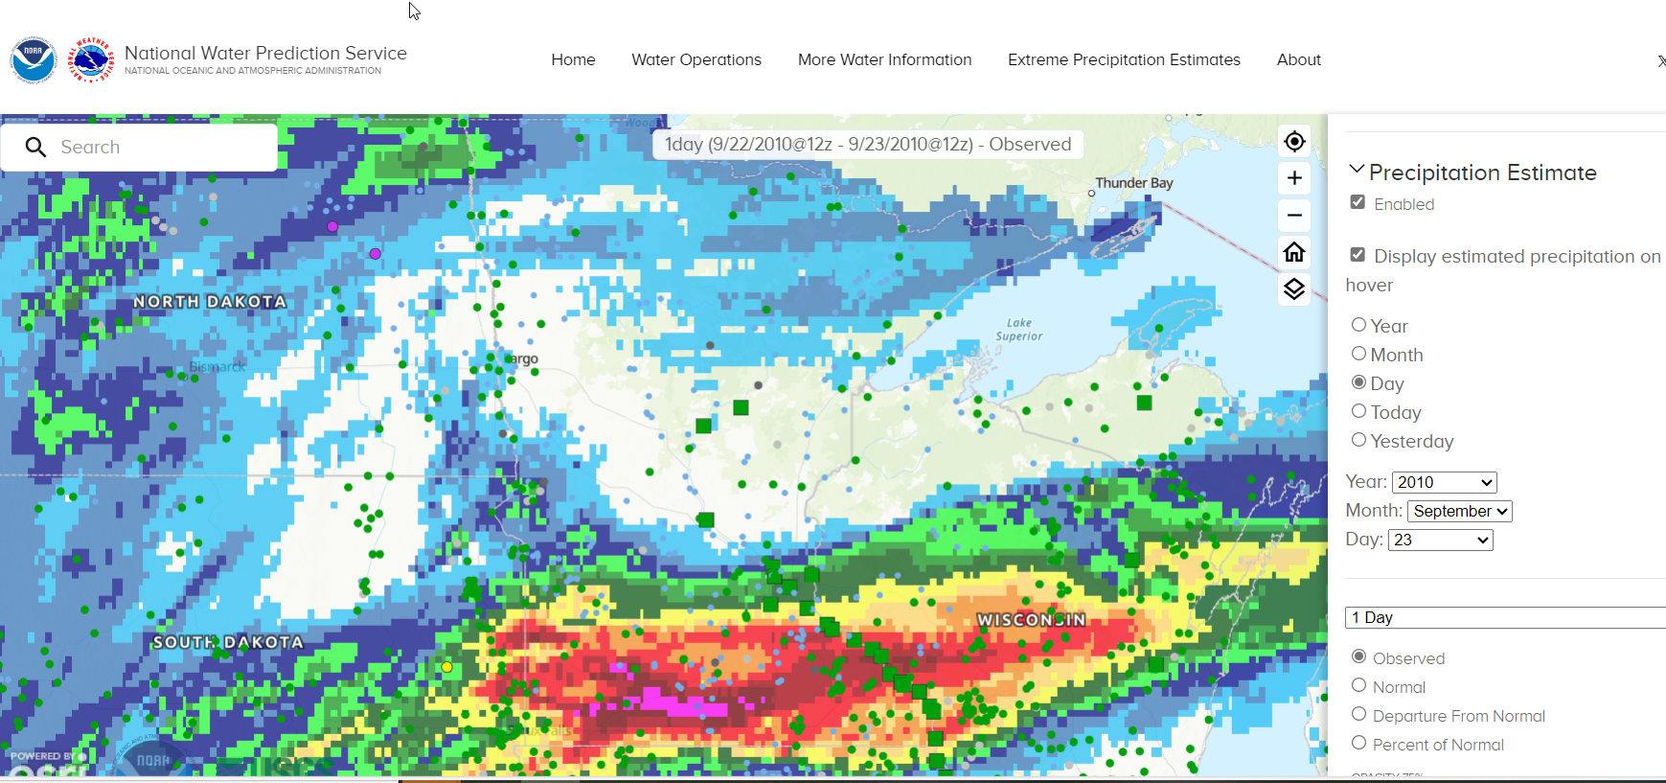

Step 4: Hover over the location to determine the estimated precipitation for the day.
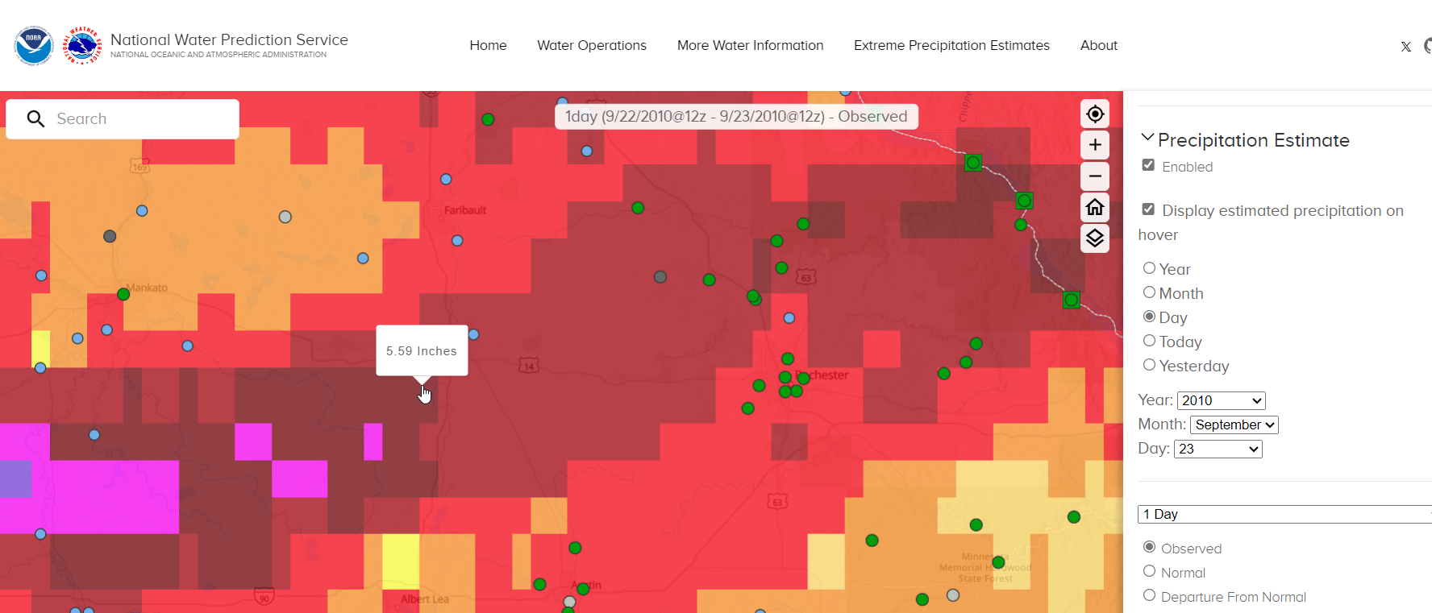
Step 5: View the date before and date after to capture the entire flooding event.
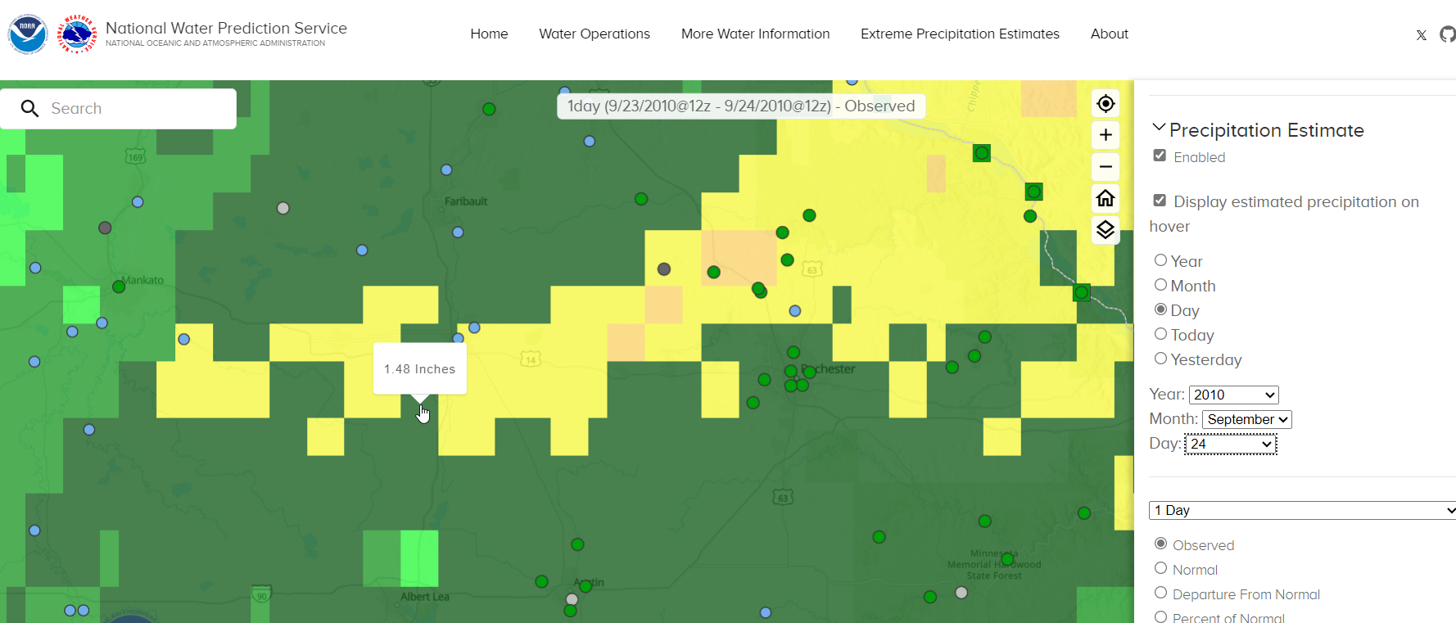
Step 6: If the flooding event took place over multiple days, add the precipitation totals together. For example, in this September 2010 event: 5.59”+1.48” = 7.07”

Instructions continue on next page

- Use Atlas 14 to determine the approximate recurrence interval of the flooding event: PF Map: Contiguous US (noaa.gov)
Step 7: Double clicking the asset/facility location on the map returns the Precipitation Frequency Estimates at various Durations (rows) and Average Recurrence Intervals (columns). Use this table to compare your precipitation total (e.g. 7.07”) to the event duration (e.g. 24-48 hours). For example, a 7.07” 24-48 hour precipitation event falls in the 50- to 100-year recurrence interval. Cite the recurrence interval in your response to demonstrate the frequency of heavy precipitation events.
